Financial Research AI Agent Development
Indian Stock Analysis Assistant

1. Overview
The Financial Research Agentic AI System is an intelligent financial analysis platform designed to assist users in obtaining comprehensive insights about stocks, companies, and market trends through natural language interactions. The system combines the capabilities of large language models with autonomous agent workflows and real-time financial data sources to provide accurate, contextual, and explainable financial analysis. Instead of relying on a single static model, the platform employs an agent-based architecture in which specialized tools collaborate to collect information, perform analysis, and generate meaningful responses.
The primary objective of the system is to simplify financial research by transforming raw market data into actionable insights. Users can submit queries regarding stock performance, company fundamentals, analyst opinions, or recent market developments, and the system automatically determines the appropriate sequence of operations required to answer the request. Through intelligent orchestration, the platform retrieves structured financial information, gathers recent news and market updates, analyzes the collected data, and produces comprehensive responses in natural language.
The architecture integrates multiple technologies to ensure efficient and reliable analysis. Historical stock prices, financial ratios, company fundamentals, and market statistics are obtained through Yahoo Finance, while current events and news articles are collected using web-search capabilities provided by Tavily Search. These heterogeneous data sources are consolidated and supplied to the reasoning engine powered by Google Gemini, which interprets the information and generates analytical insights. The entire workflow is coordinated through LangGraph, which enables agent orchestration, task planning, state management, and memory preservation.
A key characteristic of the system is its agentic approach. Unlike traditional applications that follow a fixed execution sequence, the Financial Research Agentic AI dynamically determines which tools are required based on the user's request. The agents collaborate to decompose tasks, retrieve information from relevant sources, process financial metrics, and synthesize the results into coherent explanations. This design improves flexibility, modularity, and adaptability while enabling the system to handle diverse financial queries effectively.
The architecture follows a layered and modular design consisting of the user interaction layer, agent orchestration layer, external data acquisition layer, reasoning and analysis layer, and response generation layer. Each layer performs independent responsibilities, thereby enhancing maintainability, scalability, and extensibility. Additional tools, APIs, and analytical modules can be incorporated into the framework without disrupting the overall workflow.

2.Purpose of the System
The purpose of the Financial Research Agentic AI System is to provide an intelligent platform that assists users in performing financial research and investment analysis through natural language interactions. The system aims to eliminate the complexity involved in gathering and interpreting financial information by automating the processes of data retrieval, analysis, and insight generation. It enables users to access real-time stock information, company fundamentals, market trends, and recent news from multiple sources within a unified environment.
The platform leverages artificial intelligence and agent-based workflows to transform raw financial data into meaningful and understandable information. Through automated reasoning and contextual analysis, the system helps users evaluate company performance, understand market sentiment, identify trends, and obtain analytical summaries. The ultimate objective is to support investors, students, researchers, and financial enthusiasts in making informed decisions based on reliable and up-to-date information.

3. Scope
The system supports stock analysis for Indian companies listed on NSE and BSE. It provides historical price analysis, company fundamentals, sentiment analysis, technical indicators, portfolio management, and report generation functionalities. Users can interact with the AI assistant to obtain explanations and insights regarding financial metrics and market conditions.
The scope of the application is limited to analytical and educational purposes and does not perform automatic trading or provide guaranteed investment recommendations. Future versions may include predictive analytics, machine learning models, and advanced portfolio optimization techniques.

4. System Architecture
The architecture follows a layered design consisting of five major layers:

User Interface Layer: Provides interaction with users through Streamlit.

Data Acquisition Layer : Retrieves stock data and news information from external APIs.

Processing Layer : Performs technical indicator calculations and sentiment analysis.

AI Layer : Generates intelligent responses using Google Gemini.

Report Generation Layer : Creates downloadable PDF reports.

User Interface
(Streamlit)
Data Acquisition Layer
Yahoo Finance + News API

Processing layer
RSI + SMA +
TextBlob

AI Layer
Google Gemini
5. Component Architecture
The application consists of six major components:

User Interface Module
Developed using Streamlit, this module accepts user input and displays visualizations and reports.

Data Retrieval Module
Uses Yahoo Finance and News API to fetch market data and financial news.

Technical Analysis Module
Calculates RSI, moving averages, and stock trends.

Sentiment Analysis Module
Uses TextBlob to determine market sentiment from news articles.

AI Chat Module
Integrates Google Gemini to provide summaries and answer financial queries.

Report Generation Module
Generates professional PDF reports using FPDF2.
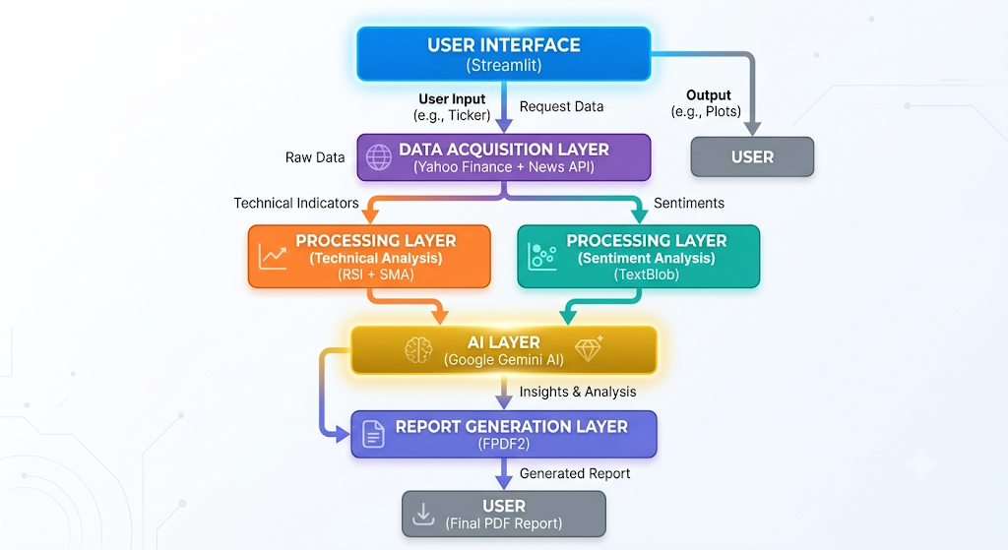
Fig 1 : Component Architecture
6. Financial Data Flow
The Financial Research AI System follows a sequential data flow architecture in which information moves through multiple processing stages before being presented to the user. The flow begins when a user submits a stock symbol or financial query through the Streamlit interface. Based on the request, the system dynamically retrieves stock information, market news, and company fundamentals from external data sources.
Initially, the Data Acquisition Layer communicates with the Yahoo Finance API to obtain historical stock prices, current market values, trading volume, company information, financial ratios, and other fundamental indicators. Simultaneously, the News API collects recent news articles related to the selected company or stock. These external sources provide both quantitative and qualitative information required for analysis.
Once the data is retrieved, it is transferred to the Processing and Analytics Layer. Historical price data is used to calculate technical indicators such as Simple Moving Average (SMA), Relative Strength Index (RSI), and other performance metrics. The processed information is then aggregated into a structured format that combines financial metrics with sentiment scores and market trends.
The structured dataset is supplied to the Artificial Intelligence Layer, where Google Gemini analyzes the collected information and generates meaningful interpretations, company summaries, and investment insights. The AI model transforms numerical and textual data into understandable explanations that help users interpret market conditions and company performance.
After analysis, the processed information is forwarded to the Visualization and Report Generation Layer. Plotly creates interactive charts and graphs representing stock trends and technical indicators, while FPDF2 generates downloadable PDF reports containing company fundamentals, stock performance metrics, sentiment analysis results, and AI-generated summaries.
Finally, the generated insights, visualizations, and reports are displayed to the user through the Streamlit interface. User portfolios and watchlists are stored and managed using SQLite, enabling persistent storage and future retrieval of investment-related information. Thus, the system transforms raw financial information into structured analytical reports through a continuous flow of data across acquisition, processing, analysis, visualization, and presentation stages.
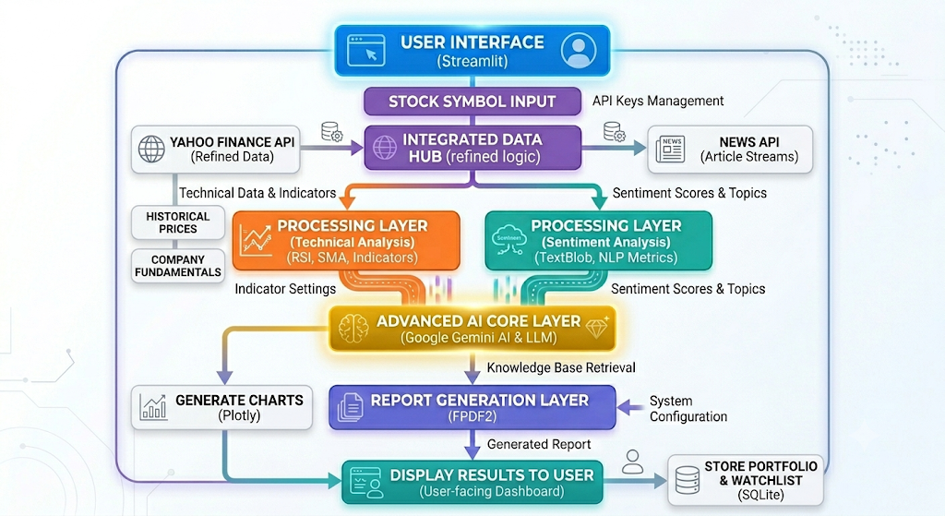
Fig 2 : Financial Flow Diagram

7. Module Description
The Financial Research AI System is composed of several independent modules that work together to provide comprehensive stock analysis and intelligent financial insights. Each module performs a specific task and communicates with other modules to ensure smooth data processing and report generation.

User Interface Module
The User Interface Module is developed using Streamlit and acts as the entry point of the application. It allows users to interact with the system by entering stock symbols, viewing charts, accessing portfolio information, and generating financial reports. The interface provides an interactive and user-friendly environment for financial analysis.

Data Retrieval Module
The Data Retrieval Module is responsible for collecting stock-related information from external sources. It communicates with Yahoo Finance to obtain historical prices, company fundamentals, earnings information, market capitalization, and financial ratios. It also retrieves current news articles from NewsAPI to provide users with the latest market developments.

Technical Analysis Module
This module processes historical stock prices and computes important technical indicators such as Simple Moving Average (SMA), Relative Strength Index (RSI), and trend analysis metrics. These indicators help users understand stock momentum and market behavior.

Sentiment Analysis Module
The Sentiment Analysis Module utilizes TextBlob to analyze financial news articles and determine the sentiment associated with market events. Based on the polarity score, the module classifies news sentiment into positive, negative, or neutral categories, enabling users to understand public perception and market reactions.

Artificial Intelligence Module
Google Gemini serves as the AI engine of the system. It processes financial metrics and news information to generate intelligent summaries, company explanations, and investment insights. The AI module enables users to interact with the system through natural language and obtain meaningful interpretations of financial data.

Database Module
SQLite is employed for maintaining watchlists and portfolio records. The database stores information related to stock symbols, quantities, purchase prices, and transaction dates. This enables persistent storage and retrieval of user-specific financial information.

Visualization and Report Generation Module
Plotly is used to create interactive charts representing stock performance and technical indicators. FPDF2 generates downloadable PDF reports containing company fundamentals, sentiment analysis results, and AI-generated insights. This module converts analytical outputs into easily understandable formats for users.

8. API Integration Architecture
The Financial Research AI System relies on several external APIs and libraries to obtain real-time information and provide intelligent analysis. These APIs serve as the communication bridge between external data providers and the internal processing modules.
Yahoo Finance acts as the primary source of stock market information. It provides historical stock prices, current market values, company fundamentals, earnings information, and financial ratios. This data forms the foundation for technical and fundamental analysis.
The NewsAPI service supplies recent financial news articles and market updates. These articles are processed by the sentiment analysis module to determine market perception and identify potential factors influencing stock prices.
Google Gemini API provides artificial intelligence capabilities to the system. It generates stock summaries, interprets financial information, and answers user queries using natural language processing. The AI module transforms raw numerical data into meaningful insights that assist users in making informed decisions.
The integration of these APIs enables the system to combine structured financial data with textual information and generate comprehensive analytical reports. The modular architecture also facilitates future integration with additional financial services and analytical tools.

9. Database Architecture
The Financial Research AI System utilizes SQLite as a lightweight relational database for storing user-specific information. The database ensures persistent storage and efficient retrieval of watchlists and portfolio records.
The Watchlist table stores stock symbols selected by users for future monitoring. It enables users to maintain a personalized list of companies of interest and quickly access their information without repeatedly entering stock symbols.
The Portfolio table maintains information regarding purchased stocks, including quantity, purchase price, and transaction date. These records are used to calculate portfolio performance and track investment history.
The database architecture is designed to be simple, efficient, and scalable. The use of SQLite provides low overhead and easy integration with Python, making it suitable for lightweight financial applications. The architecture can be extended in future versions to support user authentication, transaction history, and report storage

10. Sequence Flow
The operation of the Financial Research AI System follows a sequence of interactions among multiple components. Initially, the user submits a stock symbol or financial query through the Streamlit interface. The request is forwarded to the Data Retrieval Module, which communicates with Yahoo Finance and NewsAPI to collect stock information and recent market news.
The retrieved information is supplied to the Technical Analysis Module and Sentiment Analysis Module. Historical stock prices are processed to calculate technical indicators, while news articles are analyzed to determine market sentiment.
After preprocessing, the information is passed to Google Gemini, which performs contextual reasoning and generates meaningful summaries and recommendations. Plotly creates interactive visualizations, and FPDF2 generates financial reports. Portfolio and watchlist data are stored in SQLite. Finally, the processed information, charts, and reports are presented to the user through the Streamlit interface.

11. Architectural Characteristics
The Financial Research AI System possesses several characteristics that contribute to its efficiency, flexibility, and maintainability.

Modularity
The architecture follows a modular approach where each module performs a specific function independently. This separation simplifies development, testing, and maintenance while reducing dependencies among components.

Scalability
The system supports the integration of additional APIs, analytical modules, and machine learning models without affecting existing functionalities. This allows future expansion of features and services.

Maintainability
The layered design improves code organization and facilitates debugging and updates. Independent modules make modifications easier and reduce the risk of affecting other components.

Real-Time Processing
The use of Yahoo Finance and NewsAPI enables the system to retrieve updated financial information dynamically. This ensures that analyses are based on current market conditions.

AI-Driven Decision Support
Google Gemini enhances the analytical capabilities of the system by converting numerical and textual information into understandable explanations and recommendations.

Interactive Visualization
Plotly provides interactive charts and graphical representations that improve the interpretation of stock performance and technical indicators.

Persistent Data Storage
SQLite enables long-term storage of watchlists and portfolio information, allowing users to maintain personalized financial records.

Extensibility
The architecture supports future enhancements such as predictive analytics, portfolio optimization, and advanced machine learning techniques.

12. Conclusion
The Financial Research AI System integrates real-time stock market information, sentiment analysis, artificial intelligence, visualization, and report generation into a unified platform. By combining technologies such as Streamlit, Yahoo Finance, NewsAPI, TextBlob, Google Gemini, SQLite, Plotly, and FPDF2, the system provides comprehensive financial insights and assists users in making informed investment decisions.
The modular architecture ensures scalability, maintainability, and extensibility while enabling seamless communication between various components. The integration of AI-driven analysis with financial data processing enhances the quality of insights and simplifies complex financial research tasks. Consequently, the system serves as an intelligent decision-support platform and provides a strong foundation for future enhancements in stock analysis and investment research.

